Guideline for “Traditional Fermented Food: Kimchi”

Hello, everyone!
Thank you for participating in “Traditional Fermented Food: Kimchi” organized by SWCIC.
This is a guideline for the program, and I hope to make a great memory with you!
<Itinerary>
Time | Contents | Place
09:30~09:40 | Gathering & orientation | Suwon city hall station Gate 10
09:40~11:00 | Transformation | Suwon→Bucheon
11:00~14:00 | Make Kimchi | Kimchi Theme Park
14:00~16:00 | Come back to Suwon | Suwon city hall station Gate 10

- We will have simple lunch with the Kimchi that we will make. Little bit of rice, pork, tofu and rice cake will be served.

<Instruction>
- Gathering on December 3(Sat) by 9:30a.m

※It takes time to move to Kimchi Theme Park. We will leave exactly at 9:30.
★★★PUNCTUALITY IS IMPORTANT! ★★★
Suwon City Hall Station Gate 10: Please refer to the map to find the place 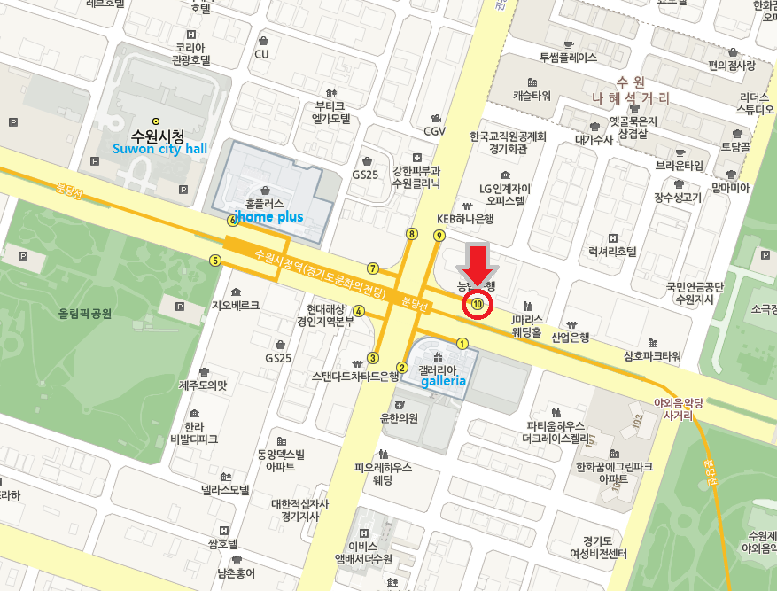
Please take Bus number 51, 52, 61, 80, 81, 82-1, 85
→ And get off at Suwon Traditional Hall Exit10
Please take Bus number 13-1, 18, 92, 92-1, 99-1, 99-2, 202, 202-1
→ And get off at Suwon Traditional Hall Exit 9

E-mail at scvakorea@gmail.com or call 031-248-9394

