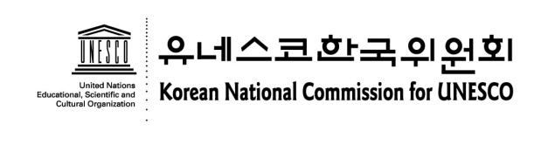
International Youth Forum on
Historical Reconciliation in East Asia
20-24 August 2012 / Seoul Youth Hostel, Seoul, Korea
Application Form

The Application Form for the International Youth Forum must be typed or clearly written in English in block letters, and submitted no later than July 22nd 2012. If you need more space for your Profile, you may add one more page and bind it using a paper clip.

1. Personal Information
Family Name (Last Name) | First Name (Given Name) | Please attach your photo here.
Gender (F / M) | Date of Birth (dd/mm/yy)
Occupation(Name of School /Organization)

English Speaking skill : High / Medium/ Low
Other Languages :

2. Contact Information
Address
Telephone No.(inc. country/area code) | Fax No. (inc. country/area code)
E-mail 1.
2.

3. Profile
⑴ Please briefly describe your educational/academic background. (150 word limit)

(2) Please give us a detailed description any academic or work experiences you had, relevant to the forum’s main theme. (150 word limit)

(3) What do you think is the role of youth for historical reconciliation in East Asia? (500 word limit / This part will be weighted HEAVILY in selection of the participants)

(4) Please add any information that you feel is relevant.

(5) Please put a number by the working group you would like to join, in the order of your personal preference. (1 being most preferred and 3 being least.)

- Working Group 1 (1st Sub-Theme) ( )
Who is the ethnic minority? The current status and challenges of ethnic minorities in each
Society.
- Working Group 2 (2nd Sub-Theme) ( )
Historical Education for Historical Reconciliation – Common History Textbook by Youth
- Working Group 3 (3rd Sub-Theme) ( )
Shared Culture in Daily Lives and Its Role for Historical Reconciliation

I hereby certify that the information given is accurate.

Signature of Applicant:
Date:

Contacts
Mr. Seong-wook Hong , Youth Team, Korean National Commission for UNESCO
Address: 26 Myeongdong-Gil, Jung-Gu, Seoul 100-810, Korea
Tel: +82-2-6958-4158 / Fax: +82-2-6958-4253 / E-mail: youth@unesco.or.kr

