Guideline for ‘Korean Traditional Handicraft’‘

Hello, everyone!
Thank you for applying for “Korean Traditional Handicraft” organized by SWCIC.
Hoping we can make a memorable time together, let me provide you with a guideline.

About ‘Korean Traditional Handicraft’ .
We will do Making Hyangnang, Traditional rice cake experience, Turning around Hwaseong Fortress in Korean dress

<Instruction>
- Gathering on October 15(Sat) by 13:40p.m

- Meet at Hwaseong Temporary Palace
※ Please refer to the map to find the place
(Address : 825, Jeongjo-ro, Paldal-gu, Suwon-si, Gyeonggi-do, Korea Suwon-si)

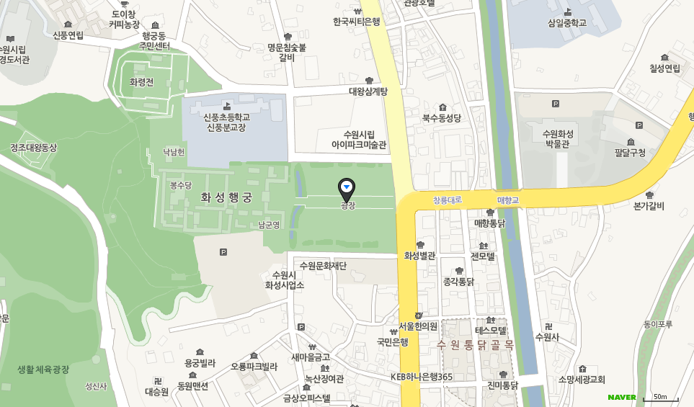

<Itinerary>
Time | contents | Place
13:40 ~ 14:00 | Gathering & Transit | Hwaseong Temporary Palace
14:00 ~ 14:10 | Orientation & Introducing | Jang-guem traditional ceremony research institute
14:10 ~ 14:50 | Making Hyangnang
15:00 ~ 15:20 | Traditional rice cake experience | Hwaseong Temporary Palace
15:00 ~ 16:00 | Turning around Hwaseong Fortress in Korean dress(Hanbok)
16:00 ~ | Arrangement and Winding-up

Please be gathered till 13:40 in front of Hwaseong Temporary Palace
Unless you arrive to meeting place till 13:50, you can not participate in .

http://jangem.kr/ For the additional information refer to the linked site
(They do not offer other langauge serivce unfortunately)

E-mail at scvakorea@gmail.com or call 031-248-9397

