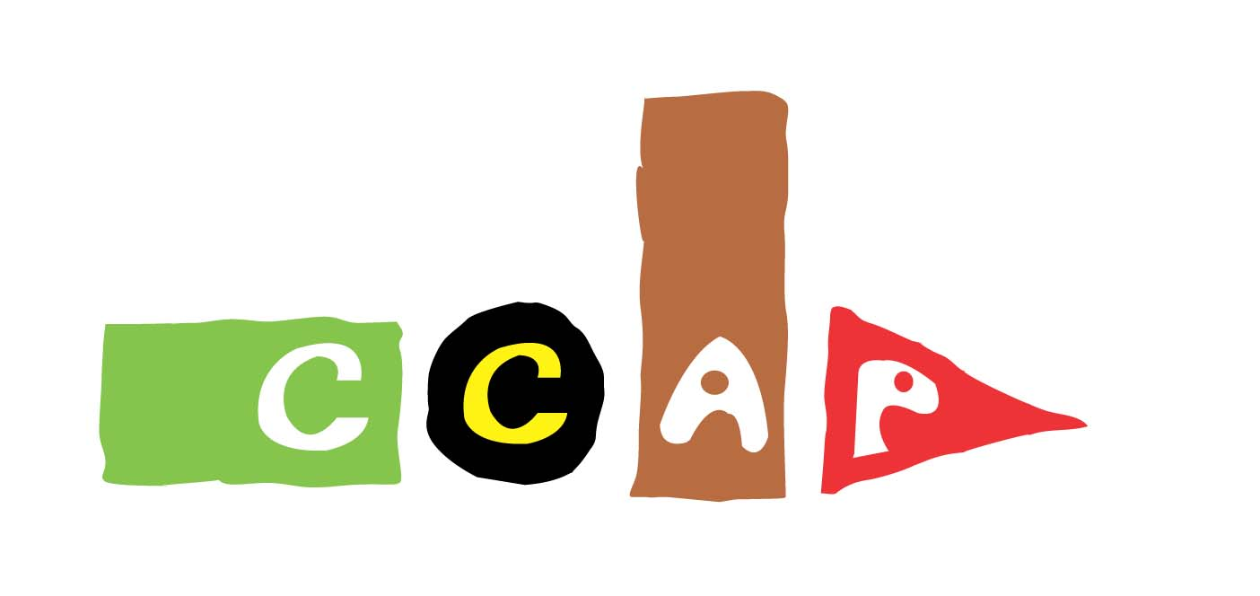Cross-Cultural Awareness Programme

- Organized by the Korean National Commission for UNESCO
- Sponsored by the Ministry of Education, Science and Technology
- Run by Suwon Youth Center since 2001 (Suwon area)

Objectives

1. To provide opportunities for all participants to share their culture
2. To enhance the multicultural understanding among the Korean youth
3. To create a constructive partnership between Koreans and global citizens

Activities
1. Regular Class
- One CEV (Cultural Exchange Volunteer) and one KIV (Korean Interpretation Volunteer) visit a pre-arranged school and conduct a culture class
- Each school has one CCAP class per month for six months per year

Spring Semester: April - June
Fall Semester: September - November

2. CCAP Workshop
- To provide participants with opportunities to experience the Korean culture
- To build up a strong friendship and network among the participants
- To visit well-known tourist spots and learn about their uniqueness

3. Evaluation Meeting
- To express our gratitude to participants for their contribution
- To evaluate and report the CCAP of the year
- To share ideas and suggestions to make a better CCAP in the future

4. Others (held by the Korean National Commission for UNESCO)
- Get-Together (June, October)
- CCAP Forum (November)
- Testimonial Dinner (December)

Associated parties of CCAP
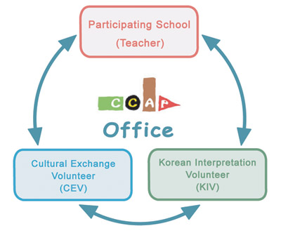
CEV Qualifications
- Foreigners of any nationality, race and culture
- Interest in cultural exchange activities
- Responsibility and cooperation are essential

Topics to be covered
  - Anything interesting that best describes your culture
  - Hands-on activities preferred
  - Trying on your traditional costume
  - Tasting your native food
  - Learning about your country’s songs and dances

Materials to be used
- Traditional clothes
- Currencies
- National flags
- Maps
- Audiovisual materials, etc.

2011 CCAP Plan
Jan - Feb | - Recruitment  - 1st Meeting with UNESCO and Local Coordinators
Mar | - Selecting Schools  - Orientation for Teachers-in-charge/ CEVs / KIVs
Apr – Jun | - Regular Class  - 1st Workshop  - 1st Get-Together (UNESCO house)
Jul – Aug | - 2nd Meeting with UNESCO and Local Coordinators  - Recruitment for the Fall Semester
Sep – Nov | - Orientation for CEVs / KIVs  - Regular Class  - 2nd Workshop  - 2nd Get-Together (UNESCO house)  - CCAP Forum (UNESCO house)
Dec | - Closing Ceremony  - Testimonial Dinner and Party (UNESCO house)

Contact
  - E-mail ccapsuwon@hanmail.net
  - Telephone: 031-218-0412 (Ms. Jahye Christine Choi)
  - Fax: 031-218-0419
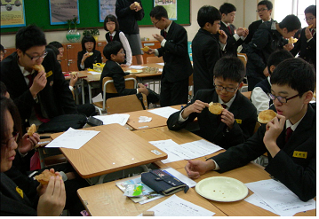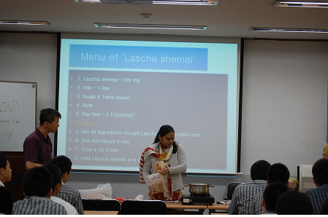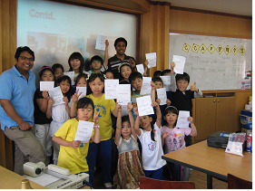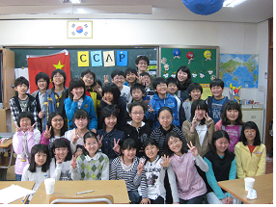Photos

Cross-Cultural Awareness Programme
Cultural Exchange Volunteer’s Profile
Photo  (Please supply  Your photo here) | Given Name |  |  |  | Family Name
 | Gender |  | F( ) M( ) |  | Date of Birth
 | Nationality |  |  |  | Passport No.
 | Alien Registration No.
Address | Korea :
 | Home Country :
Telephone | Day |  |  | Mobile Phone
 | Night |  |  | E-mail
Occupation |  |  |  | Specialty / Major
Language 1 |  |  |  | Language 2
Bank Name |  |  |  | Expected period of stay in Korea
Account No.
Time  Availability  (Please Tick) | Mon | 09:00 ~12:30 ( ) |  |  |  | 13:00 ~ 16:30 ( )
 | Tue | 09:00 ~12:30 ( ) |  |  |  | 13:00 ~ 16:30 ( )
 | Wed | 09:00 ~12:30 ( ) |  |  |  | 13:00 ~ 16:30 ( )
 | Thu | 09:00 ~12:30 ( ) |  |  |  | 13:00 ~ 16:30 ( )
 | Fri | 09:00 ~12:30 ( ) |  |  |  | 13:00 ~ 16:30 ( )
 | Sat | 09:00 ~12:30 ( ) |  |  |  | 13:00 ~ 16:30 ( )
Voluntary
Experience
Day Month 2011
Applicant Signature

Suwon Youth Foundation
Homepage: www.sycc.or.kr
Tel: 031-218-0412 (Ms. Christine Choi)

