Guideline for “Pink Spring: Hwaseong tour with cherry blossom”

Hello, everyone!
Thank you for participating in “Pink Spring: Hwaseong tour with cherry blossom” organized by SWCIC.
This is a guideline for the program, and I hope to make a great memory with you!

<Itinerary>
Time | Contents | Place
13:00 | Gathering & Orientation | Yeonmudae
13:30-15:00 | Ice breaking | Yeonmudae
15:00-15:30 | Take Hwaseong Fortress Tourist Trolley | Hwaseong Haenggung Palace
15:30-16:00 | Tour Hwaseong Haenggung Palace with a guide | Hwaseong Haenggung Palace
16:00-16:30 | Paldalsan Mountain tracking | Paldalsan Mountain
16:30-17:30 | Team mission | Gyeonggi-do Provincial Government

- Please come after having lunch! We do not offer any meals!
- There will be some food trucks around Geonggi-do Provincial Government, so you may bring some money.

<Instruction>
- Gathering on April 9(Sun) by 13:00p.m!!!

★★★ Yeonmudae: Please refer to the map to find the place 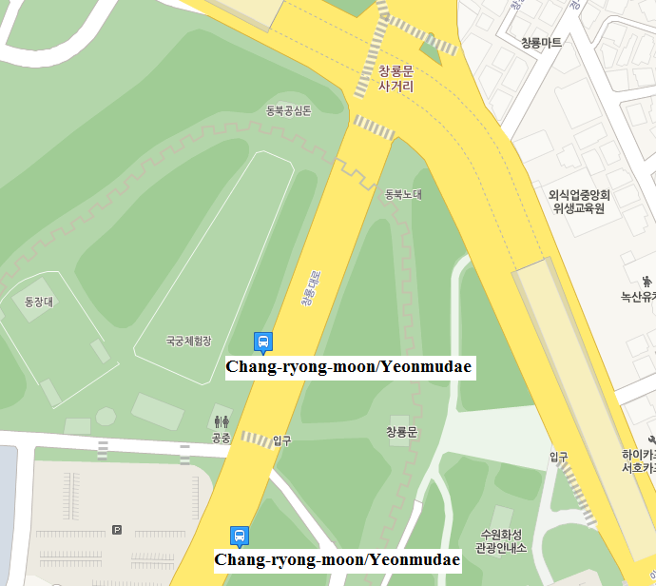
Please take Bus number 2-2, 7-2, 60, 400, 400-4, 400-5, 660, 700-2, 999, 1007, 1
→ And get off at Chang-ryong-moon/Yeonmudae (03-067)
- If you have any inquiry, please contact 010-7925-0733(Ji-seon)

