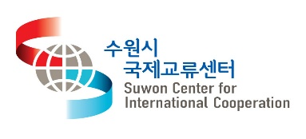
2017 Suwon Sports Festival Advertisement for International Students!

Please join us for exciting
‘Suwon Sports Festival with International Students’!

1. Introduction
「Suwon Sports Festival with International Students」is a program that international students from four representative universities in Suwon city will join for exciting sports games and memorable experience to be bounded with students all over the world!

○ Time : Nov 5, Sun. 12:50 ~ 19:30.
○ Place : Ajou Indoor Gymnasium ※ A shuttle bus will be provided for the gymnasium
○ Volume of Participants : International Students (240)
 | Foreign Students
Ajou Univ | 60
Kyonggi Univ | 60
Kyunghee Univ | 60
Sungkyunkwan Univ | 60
○ Sport Entries : Tug-of-war, bubble soccer, rope skipping, mission relay,
three-legged race, waving, flying rubber shoes, paired dodge ball, etc.
※ Entries can be changed without notice
○ Cost : Free of charge
○ Application Period : Sep 25, Mon. ~ Oct 15, Sun.
※ Participation is available on a first come first served basis
※ To gather participants with various nationalities, there might be an restriction if applicants crowded to the same nationality.
※ If you don’t show up on the day after signing up, you would be restricted to join the other events
○ Apply method :
Please follow the link to sign up (https://goo.gl/forms/2CiiIeGvRehdvXkx2)
○ Requirements : Only sneakers or running shoes are available at the gym.
○ Host : 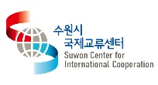, International Cooperation Committee
○ Schedule
Time | Contents | Details | Notes
12:00-12:50 | Assemble | Enrolling and welcoming
12:50-13:00 | Arrayal | Ready for the event
13:00-13:30 | Opening Ceremony | Introduction for special guests  Welcome speech  Student oath  Opening statement  Opening performance  Group Photo
13:30-15:00 | Game Part 1. | Game 1) Waving  Game 2) Three-legged race  Game 3) Rope skipping | Balanced gender ratio is recommended
15:00-15:30 | Break | Refreshment  Bonus Game
15:30-17:30 | Game Part 2. | Game 4) Flying rubber shoes  Game 5) Mission relay  Game 6) Bubble soccer  Game 7) Tug-of-war | Balanced gender ratio is recommended
17:30-18:00 | Closing Ceremony | Award ceremony and raffle prize  Closing statement
18:00-19:30 | Dinner

※ Specific schedule and sports entires are subject to change without notice.

