14th Recruiting for Climate Presenter of The Climate Reality Project, an International Environmental NGO by Al Gore

We are looking for 14^{h} Climate Presenter who will passionately devote oneself to 'The Climate Reality Project', an International Environmental NGO by Al Gore.

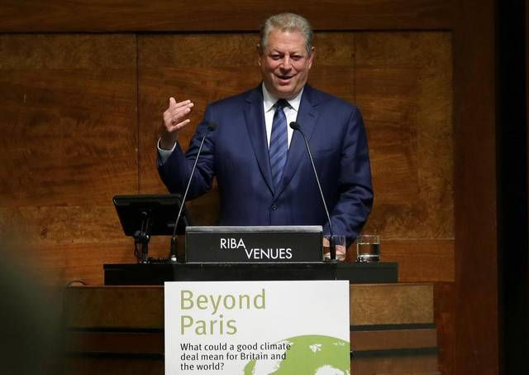
“The reality we now face implores us to act.”
- AL GORE, Founder & Chairman, The Climate Reality Project -

What is TCRP (The Climate Reality Project)?
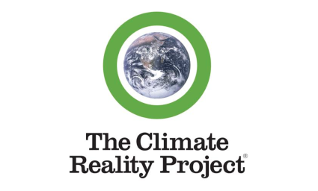

Who We Are
The goal of The Climate Reality Project is to restore sustainable environment by alerting about crisis of climate change and developing civic movement for solution. TCRP is a nonprofit Climate Change Leadership Program, which started in 2006 by Al Gore, a Nobel Laureate and former U.S. Vice President.

Currently, TCRP is operated by about 140,000 dedicated activists and to this day, it has carried out an education to more than ten million people. Therefore, TCRP aims to play a leading role in public education for climate change and expanding environmental campaign.

The Climate Reality Project is a diverse group of passionate individuals who have come together to help solve the greatest challenge of our time. We are cultural leaders, marketers, organizers, scientists, storytellers, and we are committed to building a better future together.

<Areas of Recruitment: 14th Climate Presenter >
Climate Presenter is the title for an activist of The Climate Reality Project who leads social changes to solve global environmental problems with each people around world. Climate Presenter will take charge of slideshow presentation and lead education for climate change as well as civic movements like former U.S. Vice President Al Gore did in the documentary, An Inconvenient Truth.

What You Do
Climate Presenter will take charge of environmental education for the general public whose aim is to increase public awareness of climate change problems and to encourage their intent to solve climate change problems.

Climate Presentership Program

• Training Program for Climate Presenter
- TCRP Climate Leadership Training (by Al Gore. An international event)
- Training Education for Climate Presenter

• Public Education Program for Climate Change
- TCRP Presentation / 24Hours of Reality
- Environmental education for adolescent & children

• Regular Meetings for Climate Presenter
- Education of updating information from U. S. headquarter
- Presentation and discussion about connector’s activities
(We will give you an advance notice of the schedule every month.)

• An International Event for Training Climate Presenters directly organized by former U.S. Vice President Al Gore
- TCRP REALITY LEADERSHIP CORPS TRAINING
- 24 Hours of Reality, a global event
- Promote an international event and progress the event in Korea

• Climate Reality Leadership Group Activity (must attend)
- A group activity for Climate Presenters with a training program
- This training provides the groundwork for sharing the facts and educating others about the climate crisis in a respectable, fun, digestible, and educational way. It leaves you with a sense of hope.

Climate + Action | Climate + Planning | Climate + Leadership
TCRP Presentation  ● Public education to better tell the story of climate crisis and inspire communities everywhere to take action for: college student/local government/ companies/other organizations/ Middle/High school given as a special lecture or an open lecture | PR Planning / Management Support  : Operation of planning, video production, media promotion, management support etc  ● To assist all kinds of communications with college / institution / organization / business sector  ● To e-mail e-newsletters  ● To take photos record videos during events  ● To do paper work  ● To support the management administration of TCRP Korea district | The Climate Presentership Training to play a leading role in public education for climate change and expanding environmental campaign as well as we are committed to building a better future together  ● The International Climate Presentership Training directly educated by Al Gore, founder of TCRP.  ● The local Climate Presentership Training educated by TCRP Korea District.
TCRP Action to carry out:  ● Climate Presentership training event hosted by Al Gore, former US vice president : ‘TCRP REALITY LEADERSHIP CORPS TRAINING’, Global event ‘24Hours of Reality’ etc promotion and progressing events in Korea  ● Governmental side events/project to facilitate in depth discussion on climate crisis for public as well as to become more involved in the environment campaigns and programs conducted by government agency  ● To take green action in person in order to understand climate crisis and hold campaigns to spread environment -friendly lifestyle. | Translation (English translation for educational materials & videos)  ● To translate major news, announcement, and regional information notified by TCRP HQ based in USA, from English to Korean version  ● To translate all kinds of educational resources, from English to Korean version  ●To translate the promotional materials, campaigns, initiatives, slide(PPT) decks and leadership guidelines, etc. provided by TCRP HQ based in USA, from English to Korean version | Humanitas: A call to reinvent liberal arts education  ● Questions such as,” What kind of a world are we making? What kind of a world should we be making? What kind of a world can we be making?"  ● An emphasis on action provides a special urgency to thinking. The importance of coming to grips with values like justice, equity, truth, becomes increasingly evident as we discover that interest alone cannot tell them what they need to know.  ● Being overwhelmed is the first step if you are serious about trying to get at things that really matter, on a scale that makes a difference. So what do you do when you feel overwhelmed? Well, you have two things. You have a mind. And you have other people. Start with those, and change the world.
Design (Photoshop, Illustration, etc.)
● To design for promotional material, brochure, pamphlet, newsletter

Environmental Education (Presentation) for the public
Although climate change is being serious problems, there are not many people who realize the severity of them or take action to solve them. TCRP presentation from a TCRP headquarter includes a variety of videos and pictures that help people learn more about the environmental crisis and motivate them to be active in solving the problems with a clear understanding of the cause.

Benefits of Being a Climate Presenter
- Connectors can have opportunities of climate change education and leadership program
- Connectors can gain qualification for public education related to climate change, using TCRP documents including slideshows and presentations by Al Gore.
- Connectors can have priority to participate in an international training programs for connectors such as TCRP REALITY LEADERSHIP CORPS TRAINING or 24 Hours of Reality, directly led by Al Gore
- Connectors can have a certification of TCRP Korea Climate Presenter and voluntary work. Also they can participate in the project related to environmental education.
- Where You Work
- TCRP Korea District (Seoul) / All parts of the country including Seoul

How Long You Will Work
For 6 months after the training program (You can extend your period whenever you want.)

Schedule for Recruitment
- Application deadline: Dec. 2 (Sun), 2018
- Announcement of qualified candidates and interview schedule: Will be notified later. (We will set up interviews in the order of application.)
- Interview Schedule: Will be notified individually later. (People who live far from Seoul can change the date of interview after discussion.)
- Interview Location: The Climate Reality Project, Korea District
- 1505, Ian Sangam II, 190, World Cup-ro, Mapo-gu, Seoul 03938, Korea
- Announcement of a Successful Candidate: Individually announced.

Schedule for Climate Presenter (Connector) Training Program
- Will be notified later.
- Content of Education: An introduction of TRCP and a role of NGO, TCRP presentation training, leadership training, an introduction of Climate Reality Leadership Group Activity (Climate Action, Climate Planning, Climate Leadership) as Connector’s group activity. (This training is mandatory to attend according to each one’s schedule)
- Certificate for TCRP Connector: To get a certificate, you have to finish your presentation of TCRP public education at least once after attending the training program.
- Location for Training: The Climate Reality Project, Korea District

Qualification for Application
- Those who have a lot of interests in environmental issues and who want to support environment preservation
- Those who are passionate and have a strong sense of responsibility
- Those who can give the public an education of climate change for 6 months after completing the training (You can extend your period whenever you want.)
- It doesn’t matter if you are workers, ordinary people, high school students, college students, or others.
- Age, sex, educational background, are not important to become a Connector.
- Since we have various audiovisual educational materials for environmental education, you don’t have to be an expert in presentation skills.
- Those who have a command of Korean at least minimum level or English ability

Location
The Climate Reality Project, Korea District
1505, Ian Sangam II, 190, World Cup-ro, Mapo-gu, Seoul 03938, Korea
(You can check in detail here: http://www.sgf.or.kr)
There is a building, Ian Sangam II, right in front of Exit 2 of Mapo-gu Office Station (Line 6). It will take less than one minute from the exit 2. Our office is located on the 15th floor (Room number: 1505).

How to apply
- Please apply via this link : http://naver.me/FLMROBre
- Please send this application form to climateproject@tcpkorea.org
(E-mail/File Title: ‘Climate Presenter 14th Application – Name’)

Contact
Email: climateproject@tcpkorea.org (We prefer e-mail inquiry to telephone. When you send an e-mail, the title should be: Inquiry of 14th Climate Presenter_Name)

