Sang J. Chung
School of Pharmacy, Sungkyunkwan University e-mail: sjchung@skku.edu

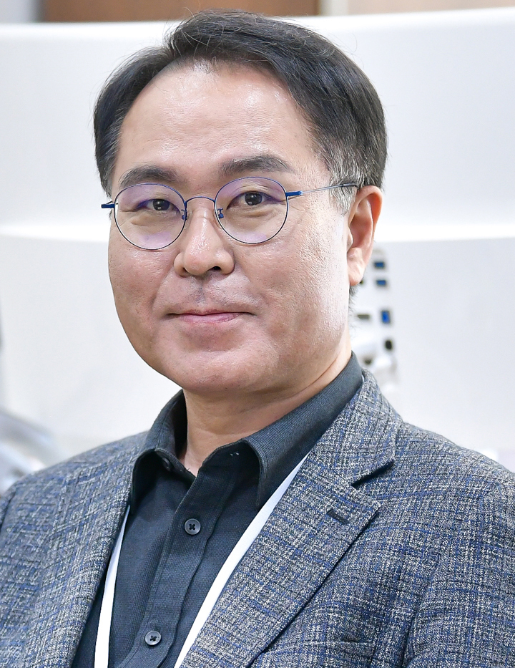
1990 BS, Pharmacy , Sungkyunkwan University
1996 PhD, Chemistry, POSTECH (advisor: Dong Han Kim)
1997-1998 Post-Doc, Scripps Res. Inst., Chemistry (advisor: Chi-Huey Wong)
2000-2003 Post-Doc, Harvard Univ., Chem & Chem. Biol. (advisor: Gregory L. Verdine)
2003-2013 Senior/Principal Scientist, KRIBB, Daejeon, Korea
2013-2017 Associate Professor & Professor, Dongguk Univ., Chemistry, Seoul, Korea
2017-Current Professor, Sungkyunkwan University, Pharmacy, Suwon, Korea

Representative Papers: 1) Org. Lett. 2020, 22, 8419.; 2) Chem. Sci., 2019, 10, 1000.; 3) Pharmacol. Res. 2019, 139, 325.

Abstract

Title: Site-specific Cross Linker for Homogeneous Antibody-Drug Conjugate (ADC)
Sang J. Chung
School of Pharmacy, Sungkyunkwan University & AbTis Co. Ltd., Suwon, Korea

Antibody-drug conjugate (ADC) technology represents the most promising platform to accommodate targeted anti-cancers from highly potent cytotoxic agents which generally show serious side effects in human application. Since a cytotoxic drug in ADC is covalently connected to an antibody it is not toxic and its pharmacokinetic property largely depends on the antibody. When ADC internalizes the cytotoxic drug is released from antibody to show the original cytotoxicity. The chemical strategy used in most clinically approved ADCs are based on harnessing the reactivity of Lys and Cys residues on antibody for conjugation leading to heterogenous mixture of ADCs. We have developed novel chemical cross-linkers which specifically acylate Lys248 of native antibodies (human IgG1, IgG2, and IgG4). Using these linkers ADC products have been prepared and tested for anticancer effect in vivo as well as in vitro. In this seminar a brief overview of ADCs and the details of our results will be presented.

