Fabrication of van der Walls stacks and their application from energy storage to AI hardware

Sang-Hoon Bae
¹Deapartment of Mechanical Engineering and Materials Science, Washington University in St. Louis, Saint Louis, MO, 63130, USA

Van der Waals (vdW) materials represent a unique class of substances held together by weak interlayer forces known as van der Waals forces. These materials typically consist of atomically thin layers, such as graphene, transition metal dichalcogenides (TMDs) like MoS2 and WSe2, and hexagonal boron nitride (h-BN), collectively referred to as 2D materials. These layers can be easily exfoliated due to the weak interlayer forces, enabling the isolation of individual atomic layers. Moreover, vdW stacks, also known as layered heterostructures, are formed by stacking these individual layers on top of each other. The weak van der Waals forces between layers allow for the assembly of these atomically thin layers into three-dimensional structures, providing new device architectures and platforms for interesting physical coupling. Recently, the development of freestanding 3D nanomembranes has introduced a new avenue for creating vdW stacks, combining 2D materials with 3D nanomembranes. This hybrid approach overcomes the limitations of traditional 2D material-based vdW stacks, suggesting various opportunities for applications.
In this discussion, I aim to explore various methodologies for producing both 2D materials and 3D nanomembranes, which serve as the fundamental building blocks for constructing vdW stacks. I will introduce the historical evolution of growth techniques for 2D materials, including sublimation-based growth, catalytic growth, kinetic-control-based growth, epitaxial growth, and non-epitaxial growth. Additionally, I will examine various layer transfer techniques to fabricate single-crystal 3D nanomembranes, providing insights into the versatile methods used to engineer these materials. As these are new materials building blocks to lead innovation for next-generation devices, I will introduce some of interesting applications made of the 2D and 3D vdW stacks such as energy storage, biomedical sensors, AI hardware.

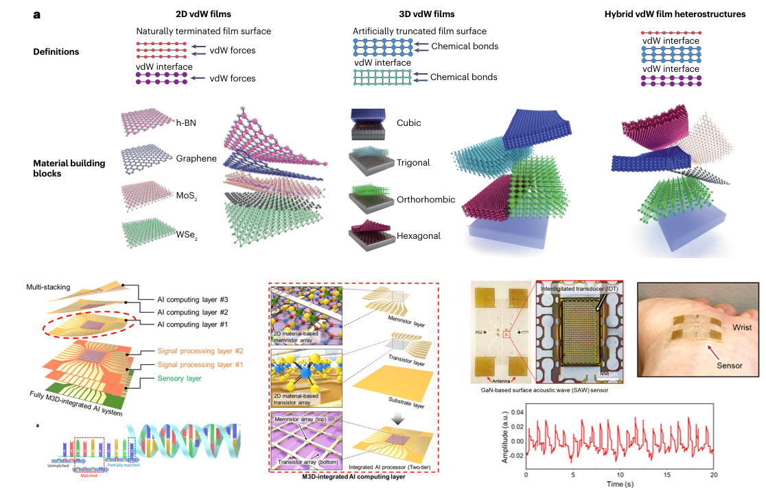
Figure. Various vdW stacks and their AI hardware and biomedical sensors

