Multimode Fiber Optics: recent paradigm shifts driving its resurgence

Siddharth Ramachandran
High Dimensional Photonics Lab, Boston University, Boston, MA, USA
sidr@bu.edu; https://sites.bu.edu/ramachandranlab/; +1-617-353-9881
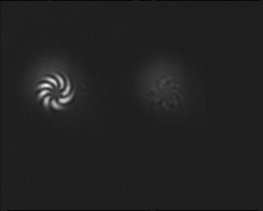
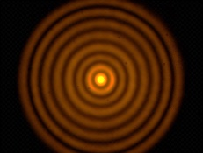
Multimode fibers theoretically support the transmission of photons in a variety of spatially, vectorially and topologically complex modes known to possess interesting linear and nonlinear properties. The large number of modes can also greatly aid energy-efficient information-capacity scaling for classical communications as well as high dimensionality for quantum networks. However, it has long been presumed that fiber-propagation mixes modes, destroying any uniquely exploitable attributes they may possess. This conventional wisdom has been upended in the last decade, due to advances in signal conditioning and reception technologies, as well as from new insights gained into the topological properties of photons. Here, we describe how this recently accessible degree of freedom for encoding information in a photon has impacted applications as disparate as quantum networks, energy-efficient internet architectures, bio-imaging, and laser power scaling.

Biography
After a B. Tech. from IIT-Kanpur and a PhD from the University of Illnois at Urbana-Champaign, Siddharth Ramachandran started his career at Bell Labs, and after a decade in industrial research labs, returned to academia, where he is currently a Distinguished Professor of Engineering at Boston University. His work on the understanding and development of lightwave devices comprising spatial, vectorial and topological complexity have been applied in the fields of quantum computing, optical networks, brain imaging, as well as laser based defense systems. For his contributions, he has been named a Distinguished Member of Technical Staff at OFS (2003), a fellow of Optica (2010), IEEE (2019), SPIE (2019), APS (2022) and AAAS (2023, an IEEE Distinguished Lecturer (2013-2015), a Distinguished Visiting Fellow of the UK Royal Society of Engineering (2016), and a Vannevar Bush Faculty Fellow (2019). He serves the optics and photonics community in several capacities, including, currently, as a deputy editor of Optica.

