Molecular Design Strategies for Redox-Active Organic Compounds and Ligands to Transition Metals

Jung Min Joo
Department of Chemistry, Kyung Hee University, Seoul 02447, South Korea
Email: jmjoo@khu.ac.kr; Twitter @jjoolab

Organic redox-active materials are used in several electrochemical applications. Their application has expanded from conventional optoelectronic devices to new energy storage systems in recent years. Therefore, the design and synthesis of redox-active organic compounds are critical for modulating their redox potentials, stability, solubility, and related properties to achieve optimal performance. In collaboration with electrochemists, we have developed heterocycle-containing redox-active organic materials for the applications as redox-flow batteries and electrochemical biosensors. The incorporation of heterocycles facilitated by C–H functionalization reactions of heterocycles was critical to control redox potentials and stability in a systematic manner. In addition, pendant substituents and counterions were carefully selected to increase solubility. Similarly, the molecular design strategies have been applied to the development of new ligands for transition-metal-catalyzed C–H functionalization reactions. New classes of bidentate ligands containing pyrazole were developed to enable Pd-catalyzed C–H functionalization of (hetero)arenes. The incorporation of pyrazole into the ligand framework provides flexibility in the binding to Pd compared to strongly binding, rigid pyridine. The catalytic applications of the pyrazole-containing ligands were successfully demonstrated in the Pd-catalyzed aerobic C−H alkenylations and perdeuteration of (hetero)aromatic compounds.

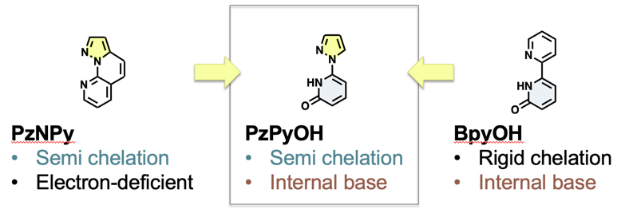
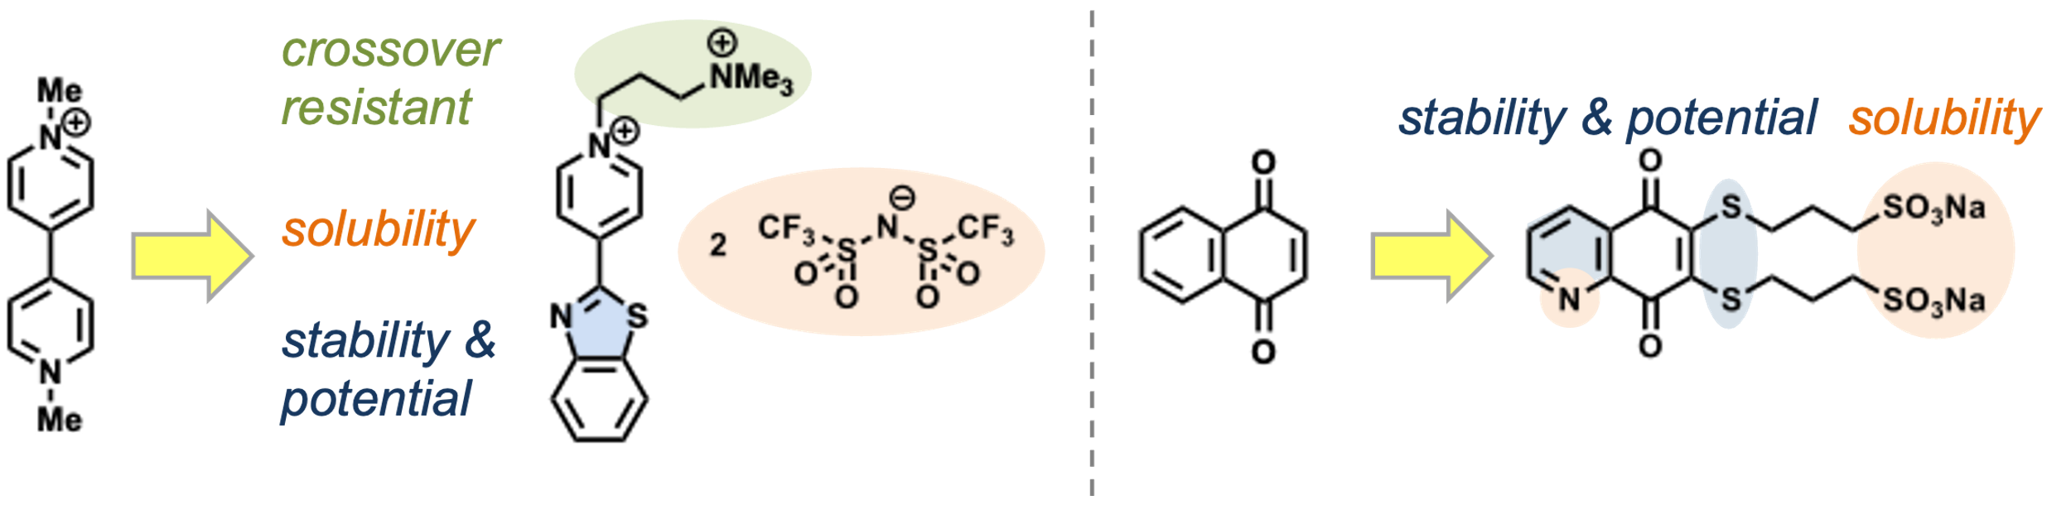

References
[1] Jeong, S.; Joo, J. M., Acc. Chem. Res. 2021, 54, 4518.
[2] Nandhakumar, P.; Lee, W.; Nam, S.; Bhatia, A.; Seo, J.; Kim, G.; Lee, N.-S.; Yoon, Y. H.; Joo, J. M.; Yang, H., Adv. Healthcare Mater. 2022, 11, 2101819.
[3] Lee, W.; Bhatia, A.; Nandhakumar, P.; Kim, G.; Joo, J. M.; Yang, H. J. Mater. Chem. B 2023, 11, 2258.
[4] Yun, S. J.; Kim, J.; Kang, E.; Jung, H.; Kim, H. T.; Kim, M.; Joo, J. M., ACS Catal. 2023, 13, 4042.

