Oligourea Helices: From Peptidomimetics to Proteiomimetics
Sung Hyun Yoo
Department of Chemistry, Chonnam National University
E-mail: sunghyun.yoo@jnu.ac.kr

N,N’-linked oligourea helices have been developed as a peptidomimetic scaffold and displayed structures and functions that have not been found from natural peptides. One of the notable progress in this realm would be their pharmaceutical properties potentially rivalling to peptide-based drugs. As an extension of peptidomimetics, protein mimics^{[2]} using oligourea helices have been expected to serve various roles of proteins.
Here, self-assembly of amphiphilic oligourea helices for the creation of protein mimics in water is introduced. First, adaptive binding mode whereby the oligourea helix bundle undergoes substantial conformational change to accommodate guest molecules in a manner reminiscent of glycolipid transfer proteins is presented.^{[3]} Secondly, environment-dependent expansion of water-filled channel reminiscent of membrane proteins is presented.^{[4]} Lastly, functionalization of oligourea helix channel with cationic pore is presented. The dynamic nature and functionalization of the self-assembling oligourea helices reported here marks a step forward in the design of functional protein mimics.
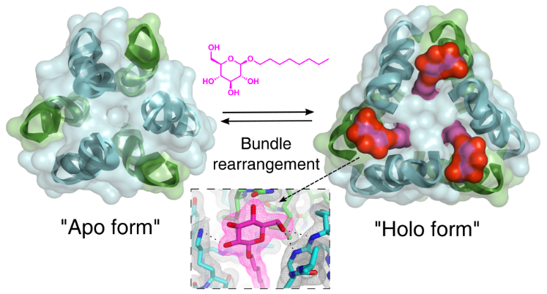
References
1. Gellman, S. H. Acc. Chem. Res. 1998, 31, 173.
2. Horne, W. S.; Grossmann, T. N. Nat. Chem. 2020, 12, 331.
3. Yoo, S. H. et al. J. Am. Chem. Soc. 2022, 139, 15988.
4. Yoo, S. H. et al. ChemPlusChem 2020, 85, 2243.

